Vysoká škola báňská - Technická univerzita Ostrava

Počítačové sítě – ZS 2019/2020 (POS)

**Projekt návrhu sítě**

**Vypracovali:** Lukáš Majoros ( MAJ0123 ) , Barbora Šamonilová ( SAM0091 )

Parametrizace: 22

------------------------------------

Firma: weiya

Číslo topologie: F

Čísla VLAN: VLAN A=131, VLAN B=140

Počty stanic na segmentech: VLAN A=36, VLAN B=38, Segment S1=30

Rozsah veřejných adres: 22.115.68.0/22

Rozsah privátních adres: 10.169.38.128/26

Rozsah IPv6 adres: 2001:1e7e:00f3:e000::/52

Zvláštní segmenty: NAT: VLAN A, DNS: Segment S1 (PC3), DHCP: VLAN B, T: Segment S1, N: Segment S1

NAT pool: 74

Směrovací protokol: OSPF

**1. část: Ekvivalentní L3 topologie a adresní plán**

**Zadaná topologie:**

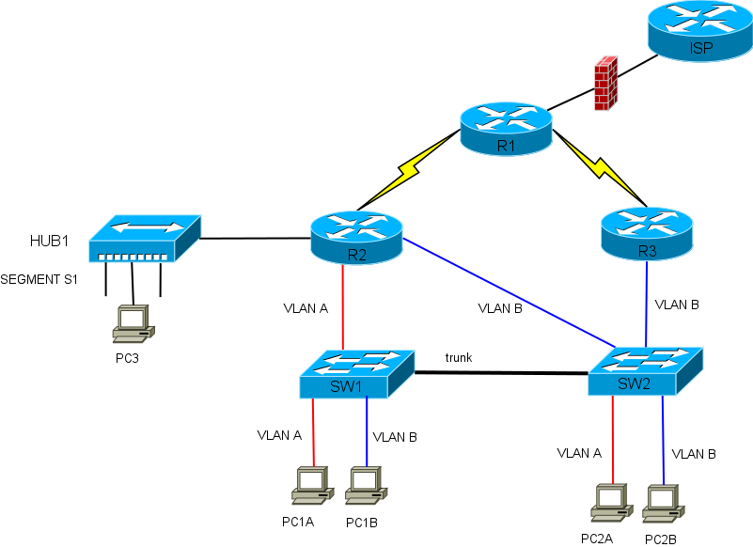

**Ekvivalentní L3 topologie:**

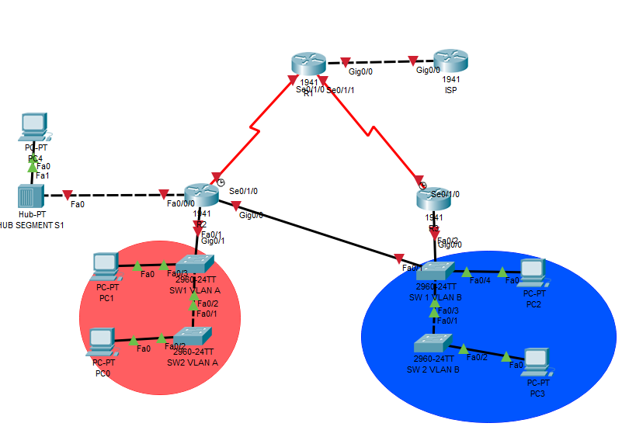

**Reálná topologie :**

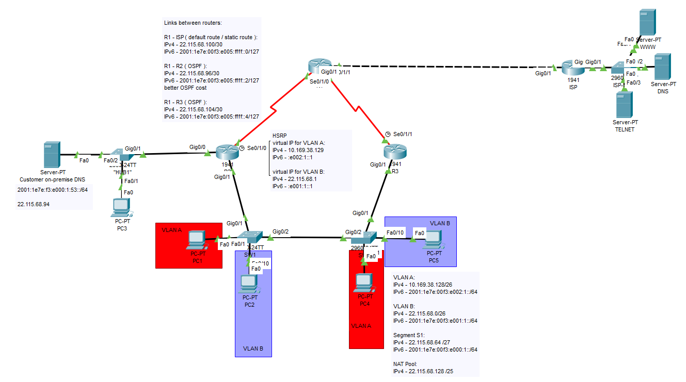

**2. část: Adresace**

**Adresní plán ( přehled ):**  
  
  
Rozsah veřejných IPv4 adres: 22.115.68.0/22

Subnet: 22.115.68.0 /22

HostMin: 22.115.68.1   
HostMax: 22.115.71.254   
Hosts/Net: 1022

Rozsah privátních IPv4 adres: 10.169.38.128/26  
Subnet: 10.169.38.128 /26   
HostMin: 10.169.38.128   
HostMax: 10.169.38.191   
Hosts/Net: 62

IPv6 adresace:  
Subnet: 2001:1E7E:00F3:E000:: /52  
HostMin: 2001:1E7E:00F3:E000:0000:0000:0000:0001   
HostMax: 2001:1E7E:00F3:EFFF:FFFF:FFFF:FFFF:FFFF  
Hosts/Net: 75557863725914323419136

**Adresní plán pro IPv4:**

|  |  |  |  |  |  |
| --- | --- | --- | --- | --- | --- |
| Segment | Subnet | Maska | Gateway | Rozsah hostů | Broadcast |
| VLAN A | 10.169.38.128 | (/26)  255.255.255.192 | R2: HSRIP VIP  10.169.38.129 (real GW 10.169.38.130)  R3: HSRIP VIP  10.169.38.129 (real GW 10.169.38.131) | .132 - .190 36 reserved 26 free | .191 |
| VLAN B | 22.115.68.0 | (/26)  255.255.255.192 | R2: HSRIP VIP  22.115.68.1 (real GW 22.115.68.2)  R3: HSRIP VIP  22.115.68.1 (real GW 22.115.68.3) | .4 - .62  38 reserved  24 free | .63 |
| Segment S1 | 22.115.68.64 | (/27)  255.255.255.224 | R2: .65 | .65 - .94  30 reserved  0 free | .95 |
| NAT Pool | 22.115.68.128 | (/25)  255.255.255.128 | - | .129 - .254  74 reserved  52 free | .255 |

|  |  |  |  |
| --- | --- | --- | --- |
| Segment | Subnet | Maska | Adresy |
| R1 – ISP | 22.115.68.100 | (/30) 255.255.255.252 | .101 / .102 |
| R1 – R2 | 22.115.68.96 | (/30) 255.255.255.252 | .97 / .98 |
| R1 – R3 | 22.115.68.104 | (/30) 255.255.255.252 | .105 / .106 |

|  |  |
| --- | --- |
| Služba | IP / Popis |
| On-premise DNS | 22.115.68.94 |
| DHCP vlan A | Na Routeru R2 |
| DHCP vlan B | Na Routeru R3 |
| DHCP Segment S1 | Na Routeru R2 |
| NAT Pool – Dynamický NAT | Na Routeru R2 |
| WWW server | 30.0.0.10 |
| Telnet server | 40.0.0.11 |
| DNS (externí) server | 50.0.0.12 |

**Adresní plán IPv6:**

|  |  |  |  |
| --- | --- | --- | --- |
| Segment | Subnet | Maska | Gateway |
| VLAN A | 2001:1e7e:00f3:e002:1:: | (/64) | R2: HSRIP VIP  2001:1e7e:00f3:e002:1::1 (real GW 2001:1e7e:00f3:e002:1::2)  R3: HSRIP VIP  2001:1e7e:00f3:e002:1::1 (real GW 2001:1e7e:00f3:e002:1::3) |
| VLAN B | 2001:1e7e:00f3:e001:1:: | (/64) | R2: HSRIP VIP  2001:1e7e:00f3:e001:2::1 (real GW 2001:1e7e:00f3:e001:2::2)  R3: HSRIP VIP  2001:1e7e:00f3:e001:2::1 (real GW 2001:1e7e:00f3:e001:2::3) |
| Segment S1 | 2001:1e7e:00f3:e000:1:: | (/64) | R2: ::1 |
| NAT Pool | NO NEED UNTIL NAT64 | (/64) | - |

|  |  |  |  |
| --- | --- | --- | --- |
| Segment | Subnet | Maska | Adresy |
| R2 – R1 | 2001:1e7e:00f3:e005:ffff::0 | (/127) | ::0 / ::1 |
| R1 – ISP | 2001:1e7e:00f3:e006:ffff::2 | (/127) | ::2 / ::3 |
| R3 – R1 | 2001:1e7e:00f3:e007:ffff::4 | (/127) | ::4 / ::5 |

|  |  |
| --- | --- |
| Služba | IP / Popis |
| On-premise DNS | 2001:1e7e:00f3:e000:1::53 |
| DHCP vlan A | Na Routeru R2 |
| DHCP vlan B | Na Routeru R3 |
| DHCP Segment S1 | Na Routeru R2 |
| NAT Pool – Dynamický NAT | Na Routeru R2 |
| WWW server | 2001:ffff:ffff:ffff:1::10 |
| Telnet server | 2001:ffff:ffff:ffff:1::11 |
| DNS (externí) server | 2001:ffff:ffff:ffff:1::12 |

**3. část: Konfigurace**

**Router 2:**

R2#sh ru

Building configuration...

Current configuration : 3648 bytes

!

version 15.1

no service timestamps log datetime msec

no service timestamps debug datetime msec

service password-encryption

security passwords min-length 5

!

hostname R2

!

!

!

enable secret 5 $1$mERr$9cTjUIEqNGurQiFU.ZeCi1

!

!

ip dhcp excluded-address 10.169.38.129 10.169.38.131

ip dhcp excluded-address 22.115.68.1 22.115.68.3

ip dhcp excluded-address 22.115.68.65

!

ip dhcp pool VLANA

network 10.169.38.128 255.255.255.192

default-router 10.169.38.129

dns-server 22.115.68.94

ip dhcp pool SEGMENT-S1

network 22.115.68.64 255.255.255.224

default-router 22.115.68.65

dns-server 22.115.68.94

!

!

!

ip cef

ipv6 unicast-routing

!

no ipv6 cef

!

ipv6 dhcp pool VLAN-A

address prefix 2001:1e7e:00f3:e002:2:1::/64 lifetime 172800 86400

dns-server 2001:1E7E:F3:E00:3::53

domain-name VSB.cz

!

ipv6 dhcp pool SEGMENT-S1

address prefix 2001:1e7e:00f3:e000:1::/64 lifetime 172800 86400

dns-server 2001:1E7E:F3:E000:1::53

domain-name VSB.cz

!

!

!

username admin password 7 0822455D0A16

!

!

license udi pid CISCO1941/K9 sn FTX1524306H-

!

!

!

!

!

!

!

!

!

ip ssh version 2

ip ssh time-out 60

no ip domain-lookup

ip domain-name VSB.cz

!

!

spanning-tree mode pvst

!

!

!

!

!

!

interface GigabitEthernet0/0

description SEGMENT S1 - OSPF - DHCP

ip address 22.115.68.65 255.255.255.224

ip nat outside

duplex auto

speed auto

ipv6 address 2001:1E7E:F3:E000:3::1/64

ipv6 ospf 1 area 0

ipv6 dhcp server SEGMENT-S1

!

interface GigabitEthernet0/1

description LAN INTERFACE - SUBINT - HSRP

no ip address

duplex auto

speed auto

!

interface GigabitEthernet0/1.131

description IPv4 / IPv6 GW VLAN A | HSRP | version 2 missing in packet tracer, ipv6 hsrp is not working

encapsulation dot1Q 131

ip address 10.169.38.131 255.255.255.192

ip nat inside

ipv6 address 2001:1E7E:F3:E002:1::2/64

ipv6 ospf 1 area 0

ipv6 dhcp server VLAN-A

standby 1 ip 10.169.38.129

standby 1 priority 255

standby 1 preempt

!

interface GigabitEthernet0/1.140

description IPv4 / IPv6 GW VLAN B | HSRP | version 2 missing in packet tracer, ipv6 hsrp is not working

encapsulation dot1Q 140

ip address 22.115.68.2 255.255.255.192

ipv6 address 2001:1E7E:F3:E001:2::2/64

ipv6 ospf 1 area 0

standby 2 ip 22.115.68.1

standby 2 priority 1

standby 2 preempt

!

interface Serial0/1/0

ip address 22.115.68.97 255.255.255.252

ip nat outside

ipv6 address 2001:1E7E:F3:E005:FFFF::/127

ipv6 ospf 1 area 0

clock rate 128000

!

interface Serial0/1/1

no ip address

clock rate 2000000

shutdown

!

interface Vlan1

no ip address

shutdown

!

router ospf 1

router-id 2.2.2.2

log-adjacency-changes

area 0 authentication

passive-interface GigabitEthernet0/0

passive-interface GigabitEthernet0/1

passive-interface GigabitEthernet0/1.131

passive-interface GigabitEthernet0/1.140

network 10.169.38.128 0.0.0.63 area 0

network 22.115.68.0 0.0.0.63 area 0

network 22.115.68.64 0.0.0.31 area 0

network 22.115.68.128 0.0.0.127 area 0

network 22.115.68.96 0.0.0.3 area 0

!

router rip

!

ipv6 router ospf 1

router-id 2.2.2.2

log-adjacency-changes

passive-interface GigabitEthernet0/0

passive-interface GigabitEthernet0/1

passive-interface GigabitEthernet0/1.131

passive-interface GigabitEthernet0/1.140

!

ip nat pool VLAN-A 22.115.68.129 22.115.68.255 netmask 255.255.255.128

ip classless

!

ip flow-export version 9

!

!

access-list 1 permit 10.169.38.128 0.0.0.63

!

!

!

!

!

!

line con 0

password 7 0822455D0A16

!

line aux 0

!

line vty 0 1

session-limit 1

exec-timeout 5 0

password 7 0822455D0A16

login

transport input ssh

line vty 2 4

password 7 0822455D0A16

login

transport input none

line vty 5 15

password 7 0822455D0A16

login

transport input none

!

!

!

end

**Router 3:**

R3#sh ru

Building configuration...

Current configuration : 2692 bytes

!

version 15.1

no service timestamps log datetime msec

no service timestamps debug datetime msec

service password-encryption

security passwords min-length 5

!

hostname R3

!

!

!

enable secret 5 $1$mERr$9cTjUIEqNGurQiFU.ZeCi1

!

!

ip dhcp excluded-address 22.115.68.1 22.115.68.3

!

ip dhcp pool VLAN-B

network 22.115.68.0 255.255.255.192

default-router 22.115.68.1

dns-server 22.115.68.94

!

!

!

ip cef

ipv6 unicast-routing

!

no ipv6 cef

!

ipv6 dhcp pool VLAN-B

address prefix 2001:1e7e:00f3:e000:1::/64 lifetime 172800 86400

dns-server 2001:1E7E:F3:E000:6::53

domain-name VSB.cz

!

!

!

username admin password 7 0822455D0A16

!

!

license udi pid CISCO1941/K9 sn FTX1524PN50-

!

!

!

!

!

!

!

!

!

ip ssh version 2

ip ssh time-out 60

no ip domain-lookup

ip domain-name VSB.cz

!

!

spanning-tree mode pvst

!

!

!

!

!

!

interface GigabitEthernet0/0

no ip address

duplex auto

speed auto

shutdown

!

interface GigabitEthernet0/1

description LAN INT - SUBINT - HSRP

no ip address

duplex full

speed auto

!

interface GigabitEthernet0/1.131

description IPv4 / IPv6 GW VLAN A | HSRP | version 2 missing in packet tracer, ipv6 hsrp is not working

encapsulation dot1Q 131

ip address 10.169.38.130 255.255.255.192

ip helper-address 10.169.38.131

ipv6 address 2001:1E7E:F3:E002:1::3/64

ipv6 ospf 1 area 0

standby 1 ip 10.169.38.129

standby 1 priority 1

standby 1 preempt

!

interface GigabitEthernet0/1.140

description IPv4 / IPv6 GW VLAN B | HSRP | version 2 missing in

encapsulation dot1Q 140

ip address 22.115.68.3 255.255.255.192

ipv6 address 2001:1E7E:F3:E001:2::3/64

ipv6 ospf 1 area 0

ipv6 dhcp server VLAN-B

standby 2 ip 22.115.68.1

standby 2 priority 255

standby 2 preempt

!

interface Serial0/1/0

no ip address

clock rate 2000000

shutdown

!

interface Serial0/1/1

ip address 22.115.68.105 255.255.255.252

ipv6 address 2001:1E7E:F3:E007:FFFF::4/127

ipv6 ospf 1 area 0

clock rate 128000

!

interface Vlan1

no ip address

shutdown

!

router ospf 1

router-id 3.3.3.3

log-adjacency-changes

area 0 authentication

passive-interface GigabitEthernet0/0

passive-interface GigabitEthernet0/1

passive-interface GigabitEthernet0/1.131

passive-interface GigabitEthernet0/1.140

network 10.169.38.128 0.0.0.63 area 0

network 22.115.68.0 0.0.0.63 area 0

!

ipv6 router ospf 1

router-id 3.3.3.3

log-adjacency-changes

passive-interface GigabitEthernet0/0

passive-interface GigabitEthernet0/1

passive-interface GigabitEthernet0/1.131

passive-interface GigabitEthernet0/1.140

!

ip classless

!

ip flow-export version 9

!

!

!

no cdp run

!

!

!

!

!

!

line con 0

!

line aux 0

!

line vty 0 1

session-limit 1

exec-timeout 5 0

login

transport input ssh

line vty 2 4

login

!

!

!

end

**Router 1:**

R1#sh run

Building configuration...

Current configuration : 1823 bytes

!

version 15.1

no service timestamps log datetime msec

no service timestamps debug datetime msec

service password-encryption

security passwords min-length 5

!

hostname R1

!

!

!

enable secret 5 $1$mERr$9cTjUIEqNGurQiFU.ZeCi1

!

!

!

!

!

!

ip cef

ipv6 unicast-routing

!

no ipv6 cef

!

!

!

username admin password 7 0822455D0A16

!

!

license udi pid CISCO1941/K9 sn FTX152454D1-

!

!

!

!

!

!

!

!

!

no ip domain-lookup

ip domain-name VSB.cz

!

!

spanning-tree mode pvst

!

!

!

!

!

!

interface GigabitEthernet0/0

no ip address

duplex auto

speed auto

shutdown

!

interface GigabitEthernet0/1

no ip address

ip nat outside

duplex auto

speed auto

!

interface Serial0/1/0

description TO ISP PORT

ip address 22.115.68.98 255.255.255.252

ip nat inside

ipv6 address 2001:1E7E:F3:E005:FFFF::1/127

ipv6 ospf 1 area 0

!

interface Serial0/1/1

description TO ISP PORT

ip address 22.115.68.106 255.255.255.252

ip nat inside

ipv6 address 2001:1E7E:F3:E007:FFFF::5/127

ipv6 ospf 1 area 0

!

interface Vlan1

no ip address

shutdown

!

router ospf 1

router-id 1.1.1.1

log-adjacency-changes

area 0 authentication

redistribute static

redistribute connected

passive-interface GigabitEthernet0/0

network 22.115.68.100 0.0.0.3 area 0

network 22.115.68.96 0.0.0.3 area 0

network 22.115.68.104 0.0.0.3 area 0

default-information originate

!

ipv6 router ospf 1

router-id 1.1.1.1

log-adjacency-changes

passive-interface GigabitEthernet0/0

!

ip nat pool PUBLIC-IP 22.115.68.129 22.115.68.255 netmask 255.255.255.128

ip nat inside source list 10 pool PUBLIC-IP

ip classless

!

ip flow-export version 9

!

!

access-list 10 permit 22.115.68.0 0.0.0.63

access-list 10 permit 22.115.68.64 0.0.0.31

access-list 101 remark **** LAN INBOUND ****

access-list 101 remark **** ICMP IN ****

access-list 101 permit icmp any host 22.115.68.94

access-list 101 permit icmp any host 22.115.68.101

access-list 101 remark **** ICMP OUT ****

access-list 101 permit icmp 22.115.68.0 0.0.3.255 any

access-list 101 remark **** exDNS ****

access-list 101 permit tcp 22.115.68.0 0.0.3.255 any eq 53  
access-list 101 deny tcp any 22.115.68.0 0.0.3.255 eq53  
access-list 101 remark **** WWW ****

access-list 101 permit tcp any any eq www

access-list 101 permit tcp 22.115.68.0 0.0.3.255 any eq domain

access-list 101 permit tcp 22.115.68.0 0.0.3.255 any eq domain established

access-list 101 permit tcp any any eq www established

access-list 101 remark **** TELNET ****

access-list 101 permit tcp 22.115.68.64 0.0.0.31 any eq 23

access-list 101 deny tcp any any eq 23  
access-list 101 deny any any

access-list 102 remark **** LAN OUTBOUND ****

access-list 103 remark **** WAN INBOUND ****

access-list 104 remark **** WAN OUTBOUND ****!

no cdp run

!

!

!

!

!

!

line con 0

!

line aux 0

!

line vty 0 1

exec-timeout 5 0

login

transport input ssh

line vty 2 4

login

!

**Switch 1:**

SW1#sh run

Building configuration...

Current configuration : 9451 bytes

!

version 12.2

no service timestamps log datetime msec

service timestamps debug datetime msec

service password-encryption

!

hostname SW1

!

enable secret 5 $1$mERr$9cTjUIEqNGurQiFU.ZeCi1

!

!

!

no ip domain-lookup

ip domain-name VSB.CZ

!

username admin privilege 1 password 7 0822455D0A16

!

ip dhcp snooping vlan 131,140

!

spanning-tree mode pvst

spanning-tree extend system-id

spanning-tree vlan 131,140 priority 61440

!

interface FastEthernet0/1

description VLAN A DEDICATED PORT - UNUSED PORTS ARE SHUTTED DOWN

switchport access vlan 131

switchport mode access

switchport nonegotiate

switchport port-security mac-address sticky

switchport port-security aging time 10

no cdp enable

spanning-tree portfast

spanning-tree bpduguard enable

!

interface FastEthernet0/2

description VLAN A DEDICATED PORT - UNUSED PORTS ARE SHUTTED DOWN

switchport access vlan 131

switchport mode access

switchport nonegotiate

switchport port-security mac-address sticky

switchport port-security aging time 10

no cdp enable

spanning-tree portfast

spanning-tree bpduguard enable

shutdown

!

interface FastEthernet0/3

description VLAN A DEDICATED PORT - UNUSED PORTS ARE SHUTTED DOWN

switchport access vlan 131

switchport mode access

switchport nonegotiate

switchport port-security mac-address sticky

switchport port-security aging time 10

no cdp enable

spanning-tree portfast

spanning-tree bpduguard enable

shutdown

!

interface FastEthernet0/4

description VLAN A DEDICATED PORT - UNUSED PORTS ARE SHUTTED DOWN

switchport access vlan 131

switchport mode access

switchport nonegotiate

switchport port-security mac-address sticky

switchport port-security aging time 10

no cdp enable

spanning-tree portfast

spanning-tree bpduguard enable

shutdown

!

interface FastEthernet0/5

description VLAN A DEDICATED PORT - UNUSED PORTS ARE SHUTTED DOWN

switchport access vlan 131

switchport mode access

switchport nonegotiate

switchport port-security mac-address sticky

switchport port-security aging time 10

no cdp enable

spanning-tree portfast

spanning-tree bpduguard enable

shutdown

!

interface FastEthernet0/6

description VLAN A DEDICATED PORT - UNUSED PORTS ARE SHUTTED DOWN

switchport access vlan 131

switchport mode access

switchport nonegotiate

switchport port-security mac-address sticky

switchport port-security aging time 10

no cdp enable

spanning-tree portfast

spanning-tree bpduguard enable

shutdown

!

interface FastEthernet0/7

description VLAN A DEDICATED PORT - UNUSED PORTS ARE SHUTTED DOWN

switchport access vlan 131

switchport mode access

switchport nonegotiate

switchport port-security mac-address sticky

switchport port-security aging time 10

no cdp enable

spanning-tree portfast

spanning-tree bpduguard enable

shutdown

!

interface FastEthernet0/8

description VLAN A DEDICATED PORT - UNUSED PORTS ARE SHUTTED DOWN

switchport access vlan 131

switchport mode access

switchport nonegotiate

switchport port-security mac-address sticky

switchport port-security aging time 10

no cdp enable

spanning-tree portfast

spanning-tree bpduguard enable

shutdown

!

interface FastEthernet0/9

description VLAN A DEDICATED PORT - UNUSED PORTS ARE SHUTTED DOWN

switchport access vlan 131

switchport mode access

switchport nonegotiate

switchport port-security mac-address sticky

switchport port-security aging time 10

no cdp enable

spanning-tree portfast

spanning-tree bpduguard enable

shutdown

!

interface FastEthernet0/10

description VLAN B DEDICATED PORT - unused ports are shutted down!

switchport access vlan 140

switchport mode access

switchport nonegotiate

switchport port-security mac-address sticky

switchport port-security aging time 10

no cdp enable

spanning-tree portfast

spanning-tree bpduguard enable

!

interface FastEthernet0/11

description VLAN B DEDICATED PORT - unused ports are shutted down!

switchport access vlan 140

switchport mode access

switchport nonegotiate

switchport port-security mac-address sticky

switchport port-security aging time 10

no cdp enable

spanning-tree portfast

spanning-tree bpduguard enable

shutdown

!

interface FastEthernet0/12

description VLAN B DEDICATED PORT - unused ports are shutted down!

switchport access vlan 140

switchport mode access

switchport nonegotiate

switchport port-security mac-address sticky

switchport port-security aging time 10

no cdp enable

spanning-tree portfast

spanning-tree bpduguard enable

shutdown

!

interface FastEthernet0/13

description VLAN B DEDICATED PORT - unused ports are shutted down!

switchport access vlan 140

switchport mode access

switchport nonegotiate

switchport port-security mac-address sticky

switchport port-security aging time 10

no cdp enable

spanning-tree portfast

spanning-tree bpduguard enable

shutdown

!

interface FastEthernet0/14

description VLAN B DEDICATED PORT - unused ports are shutted down!

switchport access vlan 140

switchport mode access

switchport nonegotiate

switchport port-security mac-address sticky

switchport port-security aging time 10

no cdp enable

spanning-tree portfast

spanning-tree bpduguard enable

shutdown

!

interface FastEthernet0/15

description VLAN B DEDICATED PORT - unused ports are shutted down!

switchport access vlan 140

switchport mode access

switchport nonegotiate

switchport port-security mac-address sticky

switchport port-security aging time 10

no cdp enable

spanning-tree portfast

spanning-tree bpduguard enable

shutdown

!

interface FastEthernet0/16

description VLAN B DEDICATED PORT - unused ports are shutted down!

switchport access vlan 140

switchport mode access

switchport nonegotiate

switchport port-security mac-address sticky

switchport port-security aging time 10

no cdp enable

spanning-tree portfast

spanning-tree bpduguard enable

shutdown

!

interface FastEthernet0/17

description VLAN B DEDICATED PORT - unused ports are shutted down!

switchport access vlan 140

switchport mode access

switchport nonegotiate

switchport port-security mac-address sticky

switchport port-security aging time 10

no cdp enable

spanning-tree portfast

spanning-tree bpduguard enable

shutdown

!

interface FastEthernet0/18

description VLAN B DEDICATED PORT - unused ports are shutted down!

switchport access vlan 140

switchport mode access

switchport nonegotiate

switchport port-security mac-address sticky

switchport port-security aging time 10

no cdp enable

spanning-tree portfast

spanning-tree bpduguard enable

shutdown

!

interface FastEthernet0/19

description VLAN B DEDICATED PORT - unused ports are shutted down!

switchport access vlan 140

switchport mode access

switchport nonegotiate

switchport port-security mac-address sticky

switchport port-security aging time 10

no cdp enable

spanning-tree portfast

spanning-tree bpduguard enable

shutdown

!

interface FastEthernet0/20

description VLAN B DEDICATED PORT - unused ports are shutted down!

switchport access vlan 140

switchport mode access

switchport nonegotiate

switchport port-security mac-address sticky

switchport port-security aging time 10

no cdp enable

spanning-tree portfast

spanning-tree bpduguard enable

shutdown

!

interface FastEthernet0/21

description VLAN B DEDICATED PORT - unused ports are shutted down!

switchport access vlan 140

switchport mode access

switchport nonegotiate

switchport port-security mac-address sticky

switchport port-security aging time 10

no cdp enable

spanning-tree portfast

spanning-tree bpduguard enable

shutdown

!

interface FastEthernet0/22

description VLAN B DEDICATED PORT - unused ports are shutted down!

switchport access vlan 140

switchport mode access

switchport nonegotiate

switchport port-security mac-address sticky

switchport port-security aging time 10

no cdp enable

spanning-tree portfast

spanning-tree bpduguard enable

shutdown

!

interface FastEthernet0/23

description VLAN B DEDICATED PORT - unused ports are shutted down!

switchport access vlan 140

switchport mode access

switchport nonegotiate

switchport port-security mac-address sticky

switchport port-security aging time 10

no cdp enable

spanning-tree portfast

spanning-tree bpduguard enable

shutdown

!

interface FastEthernet0/24

description SPAN sniffer

switchport access vlan 666

switchport mode access

no cdp enable

!

interface GigabitEthernet0/1

description GW / TRUNK LINKS

switchport trunk allowed vlan 131,140

ip dhcp snooping trust

switchport mode trunk

spanning-tree link-type shared

spanning-tree bpduguard enable

storm-control broadcast level 50

!

interface GigabitEthernet0/2

description GW / TRUNK LINKS

switchport trunk allowed vlan 131,140

ip dhcp snooping trust

switchport mode trunk

duplex full

spanning-tree link-type shared

spanning-tree bpduguard enable

storm-control broadcast level 50

!

interface Vlan1

no ip address

shutdown

!

!

!

!

access-list 101 deny ospf any any

access-list 101 deny eigrp any any

access-list 102 deny gre any any

access-list 103 deny ospf any any

line con 0

password 7 0822455D0A16

exec-timeout 5 0

!

line vty 0 1

password 7 0822455D0A16

login local

transport input ssh

line vty 2 4

exec-timeout 5 0

password 7 0822455D0A16

login local

transport input none

line vty 5 15

exec-timeout 5 0

password 7 0822455D0A16

login local

transport input none

!

!

monitor session 1 source vlan 131

monitor session 1 destination interface Fa0/24

monitor session 2 source vlan 140

!

!

end

**Switch 2:**

SW2#sh run

Building configuration...

Current configuration : 9464 bytes

!

version 12.2

no service timestamps log datetime msec

service timestamps debug datetime msec

service password-encryption

!

hostname SW2

!

enable secret 5 $1$mERr$9cTjUIEqNGurQiFU.ZeCi1

!

!

!

no ip domain-lookup

ip domain-name VSB.CZ

!

username admin privilege 1 password 7 0822455D0A16

!

ip dhcp snooping vlan 131,140

!

spanning-tree mode pvst

spanning-tree extend system-id

spanning-tree vlan 131,140 priority 61440

!

interface FastEthernet0/1

description VLAN A DEDICATED PORT - UNUSED PORTS ARE SHUTTED DOWN

switchport access vlan 131

switchport mode access

switchport nonegotiate

switchport port-security mac-address sticky

switchport port-security aging time 10

no cdp enable

spanning-tree portfast

spanning-tree bpduguard enable

!

interface FastEthernet0/2

description VLAN A DEDICATED PORT - UNUSED PORTS ARE SHUTTED DOWN

switchport access vlan 131

switchport mode access

switchport nonegotiate

switchport port-security mac-address sticky

switchport port-security aging time 10

no cdp enable

spanning-tree portfast

spanning-tree bpduguard enable

shutdown

!

interface FastEthernet0/3

description VLAN A DEDICATED PORT - UNUSED PORTS ARE SHUTTED DOWN

switchport access vlan 131

switchport mode access

switchport nonegotiate

switchport port-security mac-address sticky

switchport port-security aging time 10

no cdp enable

spanning-tree portfast

spanning-tree bpduguard enable

shutdown

!

interface FastEthernet0/4

description VLAN A DEDICATED PORT - UNUSED PORTS ARE SHUTTED DOWN

switchport access vlan 131

switchport mode access

switchport nonegotiate

switchport port-security mac-address sticky

switchport port-security aging time 10

no cdp enable

spanning-tree portfast

spanning-tree bpduguard enable

shutdown

!

interface FastEthernet0/5

description VLAN A DEDICATED PORT - UNUSED PORTS ARE SHUTTED DOWN

switchport access vlan 131

switchport mode access

switchport nonegotiate

switchport port-security mac-address sticky

switchport port-security aging time 10

no cdp enable

spanning-tree portfast

spanning-tree bpduguard enable

shutdown

!

interface FastEthernet0/6

description VLAN A DEDICATED PORT - UNUSED PORTS ARE SHUTTED DOWN

switchport access vlan 131

switchport mode access

switchport nonegotiate

switchport port-security mac-address sticky

switchport port-security aging time 10

no cdp enable

spanning-tree portfast

spanning-tree bpduguard enable

shutdown

!

interface FastEthernet0/7

description VLAN A DEDICATED PORT - UNUSED PORTS ARE SHUTTED DOWN

switchport access vlan 131

switchport mode access

switchport nonegotiate

switchport port-security mac-address sticky

switchport port-security aging time 10

no cdp enable

spanning-tree portfast

spanning-tree bpduguard enable

shutdown

!

interface FastEthernet0/8

description VLAN A DEDICATED PORT - UNUSED PORTS ARE SHUTTED DOWN

switchport access vlan 131

switchport mode access

switchport nonegotiate

switchport port-security mac-address sticky

switchport port-security aging time 10

no cdp enable

spanning-tree portfast

spanning-tree bpduguard enable

shutdown

!

interface FastEthernet0/9

description VLAN A DEDICATED PORT - UNUSED PORTS ARE SHUTTED DOWN

switchport access vlan 131

switchport mode access

switchport nonegotiate

switchport port-security mac-address sticky

switchport port-security aging time 10

no cdp enable

spanning-tree portfast

spanning-tree bpduguard enable

shutdown

!

interface FastEthernet0/10

description VLAN B DEDICATED PORT - unused ports are shutted down!

switchport access vlan 140

switchport mode access

switchport nonegotiate

switchport port-security mac-address sticky

switchport port-security aging time 10

no cdp enable

spanning-tree portfast

spanning-tree bpduguard enable

!

interface FastEthernet0/11

description VLAN B DEDICATED PORT - unused ports are shutted down!

switchport access vlan 140

switchport mode access

switchport nonegotiate

switchport port-security mac-address sticky

switchport port-security aging time 10

no cdp enable

spanning-tree portfast

spanning-tree bpduguard enable

shutdown

!

interface FastEthernet0/12

description VLAN B DEDICATED PORT - unused ports are shutted down!

switchport access vlan 140

switchport mode access

switchport nonegotiate

switchport port-security mac-address sticky

switchport port-security aging time 10

no cdp enable

spanning-tree portfast

spanning-tree bpduguard enable

shutdown

!

interface FastEthernet0/13

description VLAN B DEDICATED PORT - unused ports are shutted down!

switchport access vlan 140

switchport mode access

switchport nonegotiate

switchport port-security mac-address sticky

switchport port-security aging time 10

no cdp enable

spanning-tree portfast

spanning-tree bpduguard enable

shutdown

!

interface FastEthernet0/14

description VLAN B DEDICATED PORT - unused ports are shutted down!

switchport access vlan 140

switchport mode access

switchport nonegotiate

switchport port-security mac-address sticky

switchport port-security aging time 10

no cdp enable

spanning-tree portfast

spanning-tree bpduguard enable

shutdown

!

interface FastEthernet0/15

description VLAN B DEDICATED PORT - unused ports are shutted down!

switchport access vlan 140

switchport mode access

switchport nonegotiate

switchport port-security mac-address sticky

switchport port-security aging time 10

no cdp enable

spanning-tree portfast

spanning-tree bpduguard enable

shutdown

!

interface FastEthernet0/16

description VLAN B DEDICATED PORT - unused ports are shutted down!

switchport access vlan 140

switchport mode access

switchport nonegotiate

switchport port-security mac-address sticky

switchport port-security aging time 10

no cdp enable

spanning-tree portfast

spanning-tree bpduguard enable

shutdown

!

interface FastEthernet0/17

description VLAN B DEDICATED PORT - unused ports are shutted down!

switchport access vlan 140

switchport mode access

switchport nonegotiate

switchport port-security mac-address sticky

switchport port-security aging time 10

no cdp enable

spanning-tree portfast

spanning-tree bpduguard enable

shutdown

!

interface FastEthernet0/18

description VLAN B DEDICATED PORT - unused ports are shutted down!

switchport access vlan 140

switchport mode access

switchport nonegotiate

switchport port-security mac-address sticky

switchport port-security aging time 10

no cdp enable

spanning-tree portfast

spanning-tree bpduguard enable

shutdown

!

interface FastEthernet0/19

description VLAN B DEDICATED PORT - unused ports are shutted down!

switchport access vlan 140

switchport mode access

switchport nonegotiate

switchport port-security mac-address sticky

switchport port-security aging time 10

no cdp enable

spanning-tree portfast

spanning-tree bpduguard enable

shutdown

!

interface FastEthernet0/20

description VLAN B DEDICATED PORT - unused ports are shutted down!

switchport access vlan 140

switchport mode access

switchport nonegotiate

switchport port-security mac-address sticky

switchport port-security aging time 10

no cdp enable

spanning-tree portfast

spanning-tree bpduguard enable

shutdown

!

interface FastEthernet0/21

description VLAN B DEDICATED PORT - unused ports are shutted down!

switchport access vlan 140

switchport mode access

switchport nonegotiate

switchport port-security mac-address sticky

switchport port-security aging time 10

no cdp enable

spanning-tree portfast

spanning-tree bpduguard enable

shutdown

!

interface FastEthernet0/22

description VLAN B DEDICATED PORT - unused ports are shutted down!

switchport access vlan 140

switchport mode access

switchport nonegotiate

switchport port-security mac-address sticky

switchport port-security aging time 10

no cdp enable

spanning-tree portfast

spanning-tree bpduguard enable

shutdown

!

interface FastEthernet0/23

description VLAN B DEDICATED PORT - unused ports are shutted down!

switchport access vlan 140

switchport mode access

switchport nonegotiate

switchport port-security mac-address sticky

switchport port-security aging time 10

no cdp enable

spanning-tree portfast

spanning-tree bpduguard enable

shutdown

!

interface FastEthernet0/24

description SPAN sniffer

switchport access vlan 666

switchport mode access

no cdp enable

!

interface GigabitEthernet0/1

description GW / TRUNK LINKS

switchport trunk allowed vlan 131,140

ip dhcp snooping trust

switchport mode trunk

duplex full

spanning-tree link-type shared

spanning-tree bpduguard enable

storm-control broadcast level 50

!

interface GigabitEthernet0/2

description GW / TRUNK LINKS

switchport trunk allowed vlan 131,140

ip dhcp snooping trust

switchport mode trunk

duplex full

spanning-tree link-type shared

spanning-tree bpduguard enable

storm-control broadcast level 50

!

interface Vlan1

no ip address

shutdown

!

!

!

!

access-list 101 deny ospf any any

access-list 101 deny eigrp any any

access-list 102 deny gre any any

access-list 103 deny ospf any any

line con 0

password 7 0822455D0A16

exec-timeout 5 0

!

line vty 0 1

password 7 0822455D0A16

login local

transport input ssh

line vty 2 4

exec-timeout 5 0

password 7 0822455D0A16

login local

transport input none

line vty 5 15

exec-timeout 5 0

password 7 0822455D0A16

login local

transport input none

!

!

monitor session 1 source vlan 131

monitor session 1 destination interface Fa0/24

monitor session 2 source vlan 140

!

!

end